**ELECTRICAL DESIGN OF 2500 SQUARE FEET TWO STOREY RESIDENTIAL BUILDING**



**Submitted By**

|  |  |
| --- | --- |
| **Md. Mahdi Hasan**  **ID: 1802139** | **S M Shahariar Hossain**  **ID: 1802148** |
|  |  |

**EEE 460**

**Electrical Service Design**

Department of Electrical and Electronic Engineering

CHITTAGONG UNIVERSITY OF ENGINEERING AND TECHNOLOGY

January, 2024

Table of Contents

TABLE OF CONTENTS 3

PROJECT TITLE: 5

1 DETAIL PLAN DRAWING 5

1.1 INTRODUCTION 5

1.2 FLOORPLAN OF GROUND FLOOR 6

1.3 FLOORPLAN OF 1ST & 2ND FLOOR 7

2 FITTINGS & FIXTURES OF GROUND FLOOR 8

3 FITTINGS & FIXTURES OF 1ST & 2ND FLOOR 9

4 DESCRIPTION OF SYMBOLS USED IN FITTINGS & FIXTURES 10

*5* *CONDUIT LAYOUT OF GROUND FLOOR* 11

*6* *CONDUIT LAYOUT OF 1ST & 2ND FLOOR* 12

*7* *CONDUIT LEGENDS (WIRE RATINGS)* 13

8 *CABLING SIZE & CB RATINGS CALCULATION* 14

8.1 FOR GROUND FLOOR 14

8.1 FOR 1ST & 2ND FLOOR 16

*9* *ONE LINE DIAGRAMS (WITH CABLE SIZE)* 18

9.1 MAIN DISTRIBUTION BOARD DIAGRAM 18

9.2 SUB-DISTRIBUTION BOARD DIAGRAM (GROUND FLOOR) 18

9.3 SUB-DISTRIBUTION BOARD DIAGRAM (1ST & 2ND FLOOR) 18

9.4 SWITCH BOARD DIAGRAM (GROUND FLOOR) 19

9.5 SWITCH BOARD DIAGRAM (1ST & 2ND FLOOR) 19

*10* *LOAD STUDY ANALYSIS* 20

10.1 NUMBER OF LIGHT & FAN REQUIRED (FOR GROUND FLOOR) 20

10.2 NUMBER OF LIGHT & FAN REQUIRED (FOR 1ST & 2ND FLOOR) 24

10.3 TOTAL LOAD CALCULATION (FOR GROUND FLOOR) 29

10.4 TOTAL LOAD CALCULATION (FOR 1ST / 2ND FLOOR) 29

10.5 TOTAL LOAD CALCULATION (GROUND + 1ST + 2ND FLOOR) 29

*11* *BILL OF QUANTITY* 30

11.1 BOQ FOR GROUND FLOOR: 30

11.2 BOQ FOR 1ST & 2ND FLOOR: 30

*12* *COST ESTIMATION* 31

Project Title:

Electrical design of 2500 square feet Two storey residential building.

**Project Type:** Private

**Project Profile:**

14/B Parbatipur Dinajpur Rangpur

Road No.: 02

Post Code: 5250

# Detail Plan Drawing

## INTRODUCTION

This report presents a comprehensive design for a two-storey building, meticulously crafted to meet the functional requirements and aesthetic aspirations of the project. The structure, situated at Parbatipur,Dinajpur, is designed to serve Mr. X, taking into consideration the surrounding environment, local building codes, and the diverse needs of its occupants.The building is designed to residential, catering to the diverse needs of its future occupants. This purpose has been a driving force in shaping the architectural language and spatial configurations. The design seamlessly integrates the visions and requirements of our esteemed client, reflecting their aspirations, preferences, and practical needs. This collaborative process has been instrumental in crafting a tailored and client-centric design solution.Ensure proper distribution to avoid overloading any single circuit. Develop a lighting plan for each floor, considering the type of fixtures, their locations, and the desired lighting levels. Incorporate energy-efficient lighting solutions such as LED bulbs to reduce energy consumption. Strategically place electrical switches and outlets for convenience and functionality. Include three-way switches for areas with multiple entry points. Install GFCI (Ground Fault Circuit Interrupter) outlets in kitchens, bathrooms, and outdoor locations for enhanced safety. Choose appropriate wiring types and sizes based on the load requirements. Copper wiring is commonly used for residential applications. Separate circuits for lighting and receptacles to improve reliability and troubleshooting. It's important to engage a licensed electrical engineer or a qualified professional to ensure that the electrical design meets all safety and regulatory standards.

## *FLOORPLAN OF GROUND FLOOR*

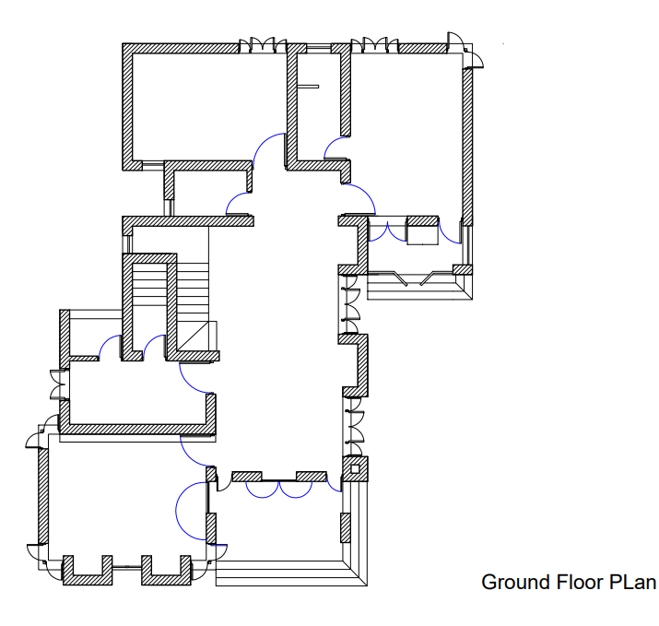

## *FLOORPLAN OF 1ST FLOOR*

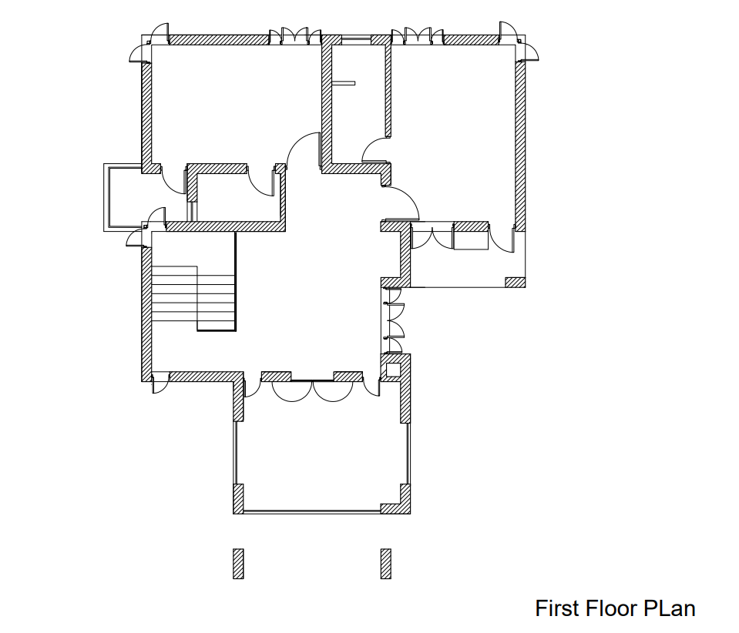

# FITTINGS & FIXTURES OF GROUND FLOOR

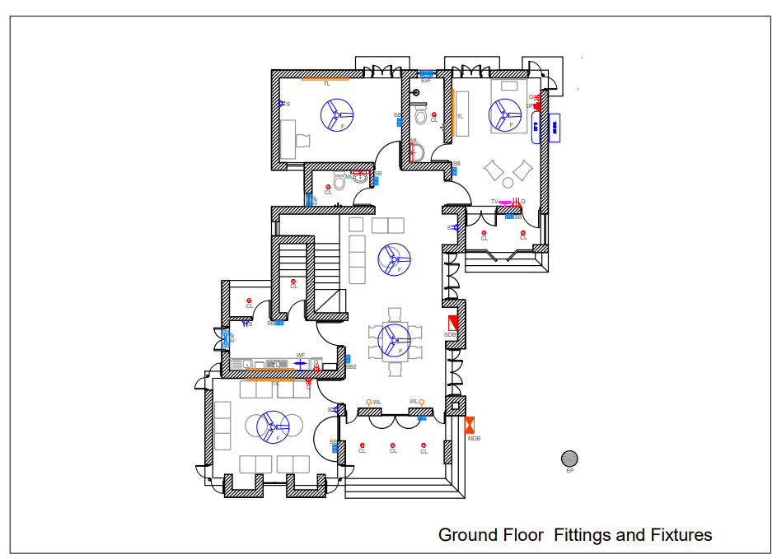

# FITTINGS & FIXTURES OF 1st FLOOR

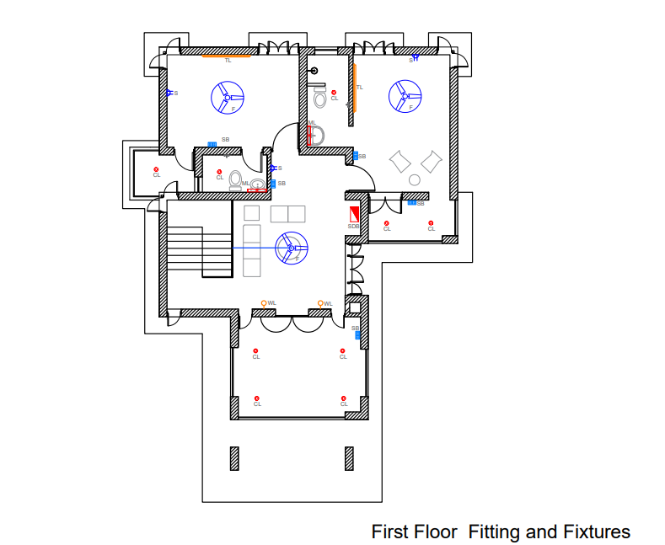

# DESCRIPTION OF SYMBOLS USED IN FITTINGS & FIXTURES

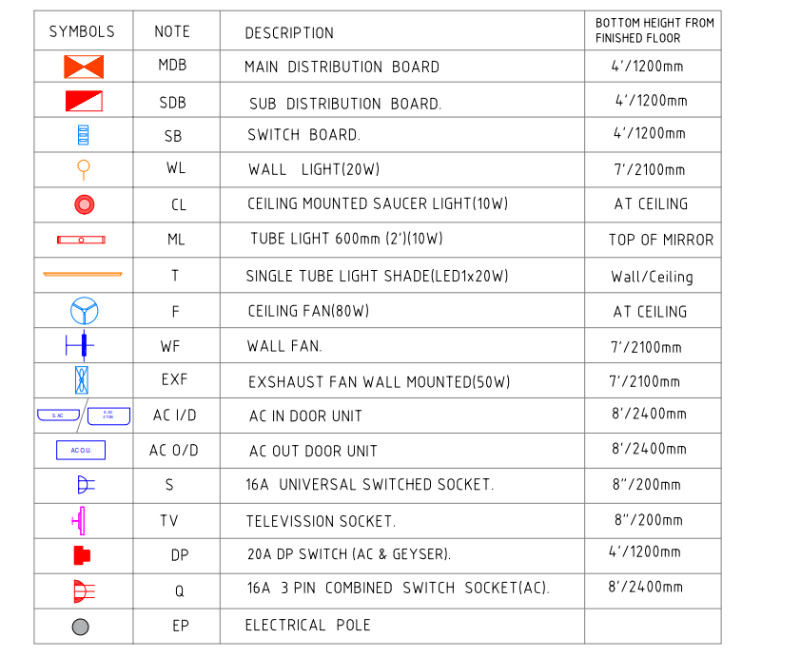

# *CONDUIT LAYOUT OF GROUND FLOOR*

# *CONDUIT LAYOUT OF 1st FLOOR*

# *CONDUIT LEGENDS (WIRE RATINGS)*

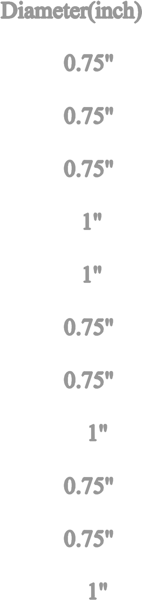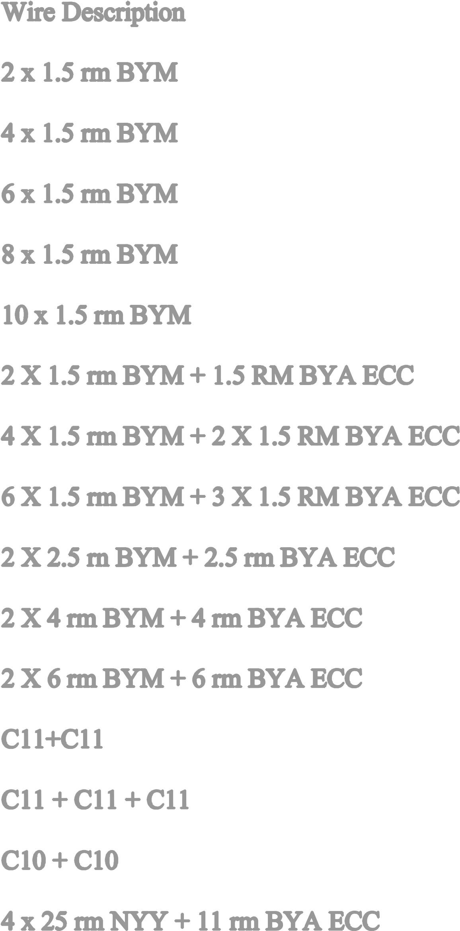

# *CABLING LAYOUT OF GROUND FLOOR*



# *CABLING LAYOUT OF FIRST FLOOR*

# *CABLING SIZE & CB RATINGS CALCULATION*

## fOR GROUND FLOOR

**To Sub Distribution Board (SDB1) of ground floor unit:**

***CKT1 Rating (SB1, SB2, SB3):***

I = (A) = 2.33 A

So, 2 x 1.5 rm BYM + 1.5 BYA ECC are used.

***CKT2 Rating (SB4, SB5):***

I = (A) = 1.69 A

So, 2 x 1.5 rm BYM + 1.5 BYA ECC are used.

**To Sub Distribution Board (SDB2) of ground floor:**

***CKT1 Rating (SB6, SB7):***

I = (A) = 2.21 A

So, 2 x 1.5 rm BYM + 1.5 BYA ECC are used.

**Calculation for SDB1(Ground Floor):**

P load= 3000 W

Q load = 4000 W

Voltage = 220 V

Power factor, pf= 0.7

CKT1 load = 20 + 20 + 20 + 100 = 160 W

CKT2 load = 60 + 20 = 80 W

CKT3 load = 20 + 100 = 120 W

Total CKT load= 160 + 80 + 120 = 360 W

SDB1(ground floor) load = 360 + 3000 * 0.5 + 4000 * 0.2 = 2660 W // P1, Q6

(Assuming, P1 and Q6 will be used 50% and 20% of the time, respectively)

SDB1(ground floor) current= 2660 / (220 * 0.7)= 17.27 A

So, **20 A SP MCCB** is needed from SDB to MDB

And **2 x 6 rm BYM + 6 rm BYA ECC is used.**

**Calculation for SDB1 (Ground Floor):**

P load= 3000 W

Q load = 4000 W

Voltage = 220 V

Power factor, pf= 0.7

CKT1 load = 20 + 20 = 40 W

CKT2 load = 60 + 20 + 100 + 20 + 20 + 60 + 20= 300 W

CKT3 load = 20 + 100 = 120 W

CKT4 load = 20 + 20 + 20 + 2 = 62 W

CKT5 load = 20 W

CKT6 load = 20 + 2 + 2 = 24 W

Total CKT load= 40 + 300 + 120 + 62 + 20 + 24 = 566 W

SDB1(ground floor) load = 566 + 4000 * 0.7 + 4000 * 0.2 = 4166 W // Q4, Q5

(Assuming, Q4 and Q5 will be used 70% and 20% of the time, respectively)

SDB1(ground floor) current= 4166 / (220 * 0.7) = 27.05 A

So, **32 A SP MCCB** is needed from SDB to MDB

And **2 x 16 rm BYM + 16 rm BYA ECC** is used.

## fOR 1ST FLOOR

**To Sub Distribution Board (SDB2) of** **1ST floor:**

***CKT1 Rating (SB1, SB2, SB3):***

I = (A) = 1.95 A

So, 2 x 1.5 rm BYM + 1.5 BYA ECC are used.

***CKT2 Rating (SB4, SB5):***

I = (A) = 1.69 A

So, 2 x 1.5 rm BYM + 1.5 BYA ECC are used.

***CKT3 Rating (SB6):***

I = (A) = 1.30 A

So, 2 x 1.5 rm BYM + 1.5 BYA ECC are used.

***CKT4 Rating (SB7):***

I = (A) = 1.56 A

So, 2 x 1.5 rm BYM + 1.5 BYA ECC are used.

**Calculation for SDB1 (1st floor):**

P load= 3000 W

Q load = 4000 W

Voltage = 220 V

Power factor, pf= 0.7

CKT1 load = 20 + 20 + 100 + 20 + 20 = 180 W

CKT2 load = 20 + 100 + 20 + 20 + 100 + 20= 280 W

CKT3 load = 100 + 60 + 20 + 20 + 100 = 300 W

CKT4 load = 20 + 20 + 100 + 20 + 100 + 20 + 100 + 100 = 480 W

Total CKT load= 180 + 280 + 300 + 480 = 1240 W

SDB1(ground floor) load = 1240 + 3000 *0.5 + 2 * 3000 * 0.3 + 3000 * 0.2 = 5140 W // P1, P2, P3, P4

SDB1(ground floor) current= 5140 / (220 * 0.7) = 33.38 A

So, **40 A SP MCCB** is needed from SDB to MDB

And **2 x 16 rm BYM + 16 rm BYA ECC** is used.

# *ONE LINE DIAGRAMS (WITH CABLE SIZE)*

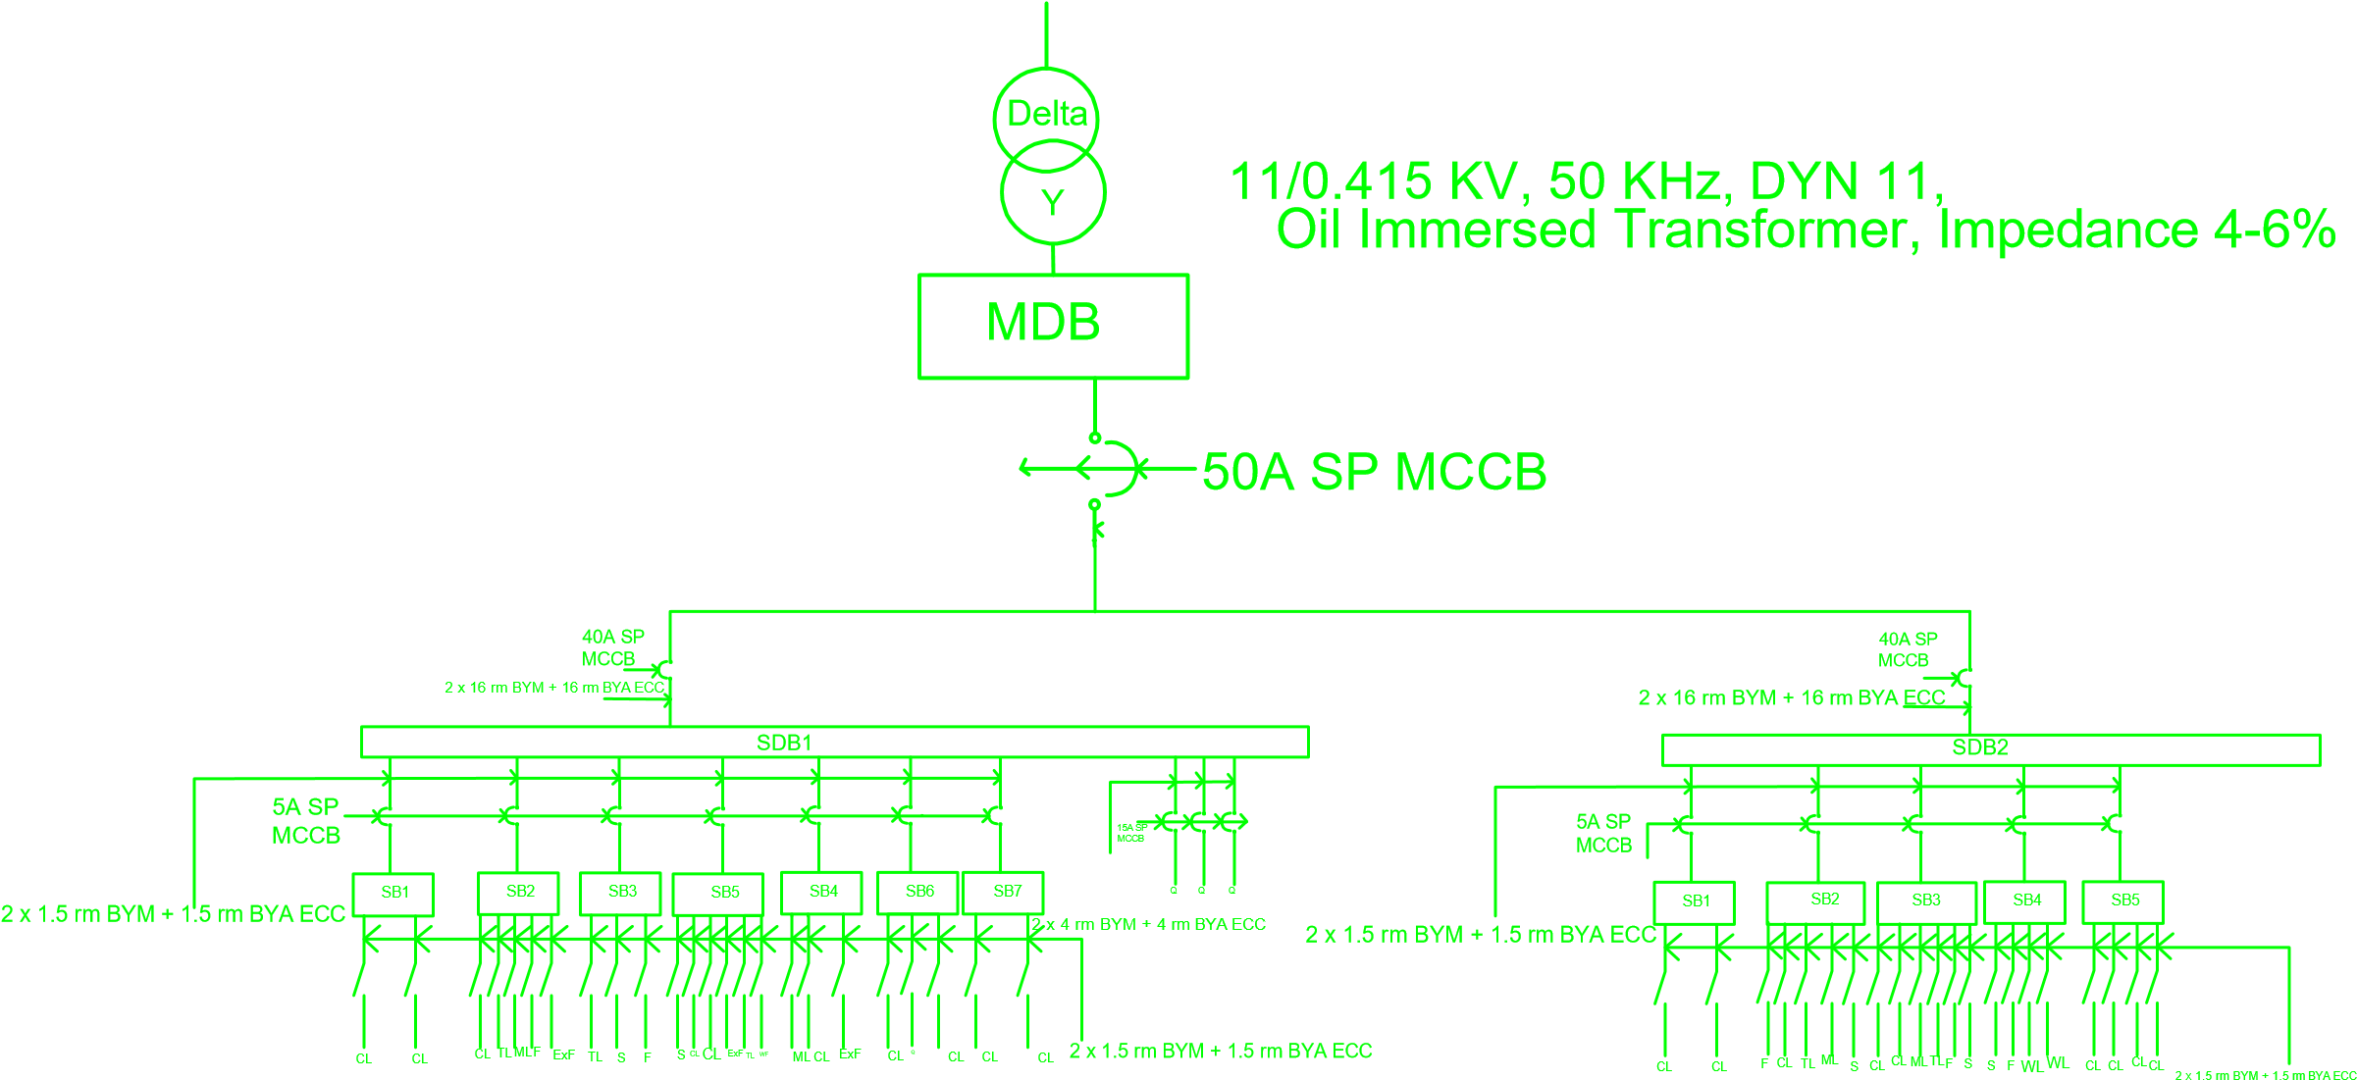

# *LOAD STUDY ANALYSIS*

## NUMBER OF LIGHT & FAN REQUIRED (FOR GROUND FLOOR)

**Ground Floor: (Single Unit)**

***Bedroom:***

Area= 11’7” x 12’8” =144.15 sqft = (144.15 x 0.092903) m2 =13.4 m2

Illuminance, E= 100 Lumen/m2

Light Loss Factor and Utilization Factor, LLF x UF = 0.7

Number of lights per illuminaire, n=1

Flux= 1250 Lumen (20W Energy Saving Bulb and Fluorescent Tube Light)

Number of Lights, N= 1.53

**So, 1 Light bulb and 1 Tube Light are required.**

Number of Fans= 1.44

**So, 1 Fan is required.**

***Veranda:***

Area= 11’7” x 2’6” =28.96 sqft = (28.96 x 0.092903)m2 =2.69 m2

Illuminance, E= 70 Lumen/m2

Light Loss Factor and Utilization Factor, LLF x UF = 0.7

Number of lights per illuminaire, n=1

Flux= 350 Lumen (8W Energy Saving Bulb and Fluorescent Tube Light)

Number of Lights, N= 0.7685

**So, 1 Ceiling Mounted Light bulb is required.**

***Kitchen:***

Area= 7’6” x 6’4” =47.475 sqft = (47.475 x 0.092903)m2 =4.4 m2

Illuminance, E= 200 Lumen/m2

Light Loss Factor and Utilization Factor, LLF x UF = 0.7

Number of lights per illuminaire, n=1

Flux= 1250 Lumen (20W Energy Saving Bulb and Fluorescent Tube Light)

Number of Lights, N= 1

**So, 1 Light bulb is required.**

Number of Fans= 0.475

**1 Exhaust Fan is required.**

***Dining Room:***

Area= 11’6” x 6’4” =72.795 sqft = (72.795 x 0.092903) m2 =6.76 m2

Illuminance, E= 100 Lumen/m2

Light Loss Factor and Utilization Factor, LLF x UF = 0.7

Number of lights per illuminaire, n=1

Flux= 1250 Lumen (20W Energy Saving Bulb and Fluorescent Tube Light)

Number of Lights, N= 0.773

**So, 1 Tube Light is required.**

Number of Fans= 0.728

**So, 1 Fan is required.**

***Dining Room (Basin Space):***

Area= 3’10” x 4’3” =16.291 sqft = (16.291 x 0.092903) m2 =1.513 m2

Illuminance, E= 100 Lumen/m2

Light Loss Factor and Utilization Factor, LLF x UF = 0.7

Number of lights per illuminaire, n=1

Flux= 350 Lumen (8W Energy Saving Bulb and Fluorescent Tube Light)

Number of Lights, N= 0.618

**So, 1 Light Bulb is required.**

***Toilet:***

Area= 3’10” x 7’4” =28.11sqft = (28.11 x 0.092903) m2 =2.611 m2

Illuminance, E= 100 Lumen/m2

Light Loss Factor and Utilization Factor, LLF x UF = 0.7

Number of lights per illuminaire, n=1

Flux= 1250 Lumen (20W Energy Saving Bulb and Fluorescent Tube Light)

Number of Lights, N= 0.2984

**So, 1 Light Bulb is required.**

**Ground Floor: (Outside Single Unit)**

***Toilet:***

Area= 6’6” x 5’ =32.5sqft = (32.5 x 0.092903)m2 =3.019 m2

Illuminance, E= 100 Lumen/m2

Light Loss Factor and Utilization Factor, LLF x UF = 0.7

Number of lights per illuminaire, n=1

Flux= 1250 Lumen (20W Energy Saving Bulb and Fluorescent Tube Light)

Number of Lights, N= 0.345

**So, 1 Light Bulb is required.**

***Guard Room:***

Area= 7’ x 6’10” + 11’6” x2’8” =78.5 sqft = (78.5 x 0.092903) m2 =7.29 m2

Illuminance, E= 100 Lumen/m2

Light Loss Factor and Utilization Factor, LLF x UF = 0.7

Number of lights per illuminaire, n=1

Flux= 1250 Lumen (20W Energy Saving Bulb and Fluorescent Tube Light)

Number of Lights, N= 0.33

**So, 1 Light Bulb is required.**

Number of Fans= 0.785

**So, 1 Fan is required.**

***Kitchen (Guard Room):***

Area= 4’ x 6’4” = 25.32 sqft = (25.32 x 0.092903)m2 =2.35 m2

Illuminance, E= 200 Lumen/m2

Light Loss Factor and Utilization Factor, LLF x UF = 0.7

Number of lights per illuminaire, n=1

Flux= 1250 Lumen (20W Energy Saving Bulb and Fluorescent Tube Light)

Number of Lights, N= 0.537

**So, 1 Light Bulb is required.**

**1 Exhaust Fan is required.**

***Generator Room:***

Area= 19.3”x12’6” =240.625 sqft = (240.625 x 0.092903)m2 =22.1375 m2

Illuminance, E= 100Lumen/m2

Light Loss Factor and Utilization Factor, LLF x UF = 0.7

Number of lights per illuminaire, n=1

Flux= 1250 Lumen (20W Energy Saving Bulb and Fluorescent Tube Light)

Number of Lights, N= 2.53

**So, 3 Tube light Bulbs is required.**

***Waiting Room:***

Area= 4’9” x 7’6” =35.625 sqft = (35.6225 x 0.092903)m2 =3.3 m2

Illuminance, E= 100Lumen/m2

Light Loss Factor and Utilization Factor, LLF x UF = 0.7

Number of lights per illuminaire, n=1

Flux= 1250 Lumen (20W Energy Saving Bulb and Fluorescent Tube Light)

Number of Lights, N= 0.377

**So, 1 Tube Light is required.**

Number of Fans = 0.356

**So, 1 fan is required.**

***Space in front of guard room, generator room and waiting room:***

Area= 5’ x 7’6” + 15’3” x7’ =144.25 sqft = (144.25 x 0.092903) m2 =13.4 m2

Illuminance, E= 100Lumen/m2

Light Loss Factor and Utilization Factor, LLF x UF = 0.7

Number of lights per illuminaire, n=1

Flux= 1250 Lumen (20W Energy Saving Bulb and Fluorescent Tube Light)

Number of Lights, N= 1.53

**So, 2 Ceiling Mounted Light Bulbs are required.**

***Garage*:**

Area= 16’10” x 27’4” + 8’4” x 7.3” = sqft = (520.4475 x 0.092903) m2 =48.35 m2

Illuminance, E= 70Lumen/m2

Light Loss Factor and Utilization Factor, LLF x UF = 0.7

Number of lights per illuminaire, n=1

Flux= 1250 Lumen (20W Energy Saving Bulb and Fluorescent Tube Light)

Number of Lights, N= 3.88

**So, 4 Ceiling Mounted Light Bulbs are required.**

***Entrance Corridor:***

Area= 8’6” x 4’6”+ 9’ x2’4”= sqft = (59.22 x 0.092903)m2 =5.5 m2

Illuminance, E= 70Lumen/m2

Light Loss Factor and Utilization Factor, LLF x UF = 0.7

Number of lights per illuminaire, n=1

Flux= 1250 Lumen (20W Energy Saving Bulb and Fluorescent Tube Light)

Number of Lights, N= 0.44

**So, 1 Ceiling Mounted Light Bulb is required.**

***Stairs:***

Area= 7’3.5” x 9’=65.625 sqft = (65.625 x 0.092903)m2 =6.09 m2

Illuminance, E= 70Lumen/m2

Light Loss Factor and Utilization Factor, LLF x UF = 0.7

Number of lights per illuminaire, n=1

Flux= 1250 Lumen (20W Energy Saving Bulb and Fluorescent Tube Light)

Number of Lights, N= 0.4872

**So, 1 Ceiling mounted Light Bulb is required.**

**Also 1 Light Bulb and 1 Fan outside the entrance gate.**

## NUMBER OF LIGHT & FAN REQUIRED (FOR 1ST & 2ND FLOOR)

***Bedroom-1:***

Area= 11’7” x 12’8” =144.15 sqft = (144.15 x 0.092903) m2 =13.4 m2

Illuminance, E= 100 Lumen/m2

Light Loss Factor and Utilization Factor, LLF x UF = 0.7

Number of lights per illuminaire, n=1

Flux= 1250 Lumen (20W Energy Saving Bulb and Fluorescent Tube Light)

Number of Lights, N= 1.53

**So, 1 Light bulbs and 1 Tube Light are required.**

Number of Fans= 1.44

**So, 1 Fan is required.**

***Bathroom:***

Area= 7’4” x 3’10” =28.11 sqft = (28.11 x 0.092903)m2 =2.61 m2

Illuminance, E= 100 Lumen/m2

Light Loss Factor and Utilization Factor, LLF x UF = 0.7

Number of lights per illuminaire, n=1

Flux= 1250 Lumen (20W Energy Saving Bulb and Fluorescent Tube Light)

Number of Lights, N= 0.298

**So, 1 Light Bulb is required.**

***Veranda:***

Area= 13’8” x 3’ =41 sqft = (41 x 0.092903)m2 =3.81 m2

Illuminance, E= 70 Lumen/m2

Light Loss Factor and Utilization Factor, LLF x UF = 0.7

Number of lights per illuminaire, n=1

Flux= 350 Lumen (20W Energy Saving Bulb and Fluorescent Tube Light)

Number of Lights, N= 1.08

**So, 1 Ceiling Mounted Light bulb is required**

***Bedroom-3:***

Area= 11’7” x 12’8” =144.15 sqft = (144.15 x 0.092903)m2 =13.4 m2

Illuminance, E= 100 Lumen/m2

Light Loss Factor and Utilization Factor, LLF x UF = 0.7

Number of lights per illuminaire, n=1

Flux= 1250 Lumen (20W Energy Saving Bulb and Fluorescent Tube Light)

Number of Lights, N= 1.53

**So, 1 Light bulbs and 1 Tube Light are required.**

Number of Fans= 1.44

**So, 1 Fan is required.**

***Bathroom:***

Area= 7’4” x 3’10” =28.11 sqft = (28.11 x 0.092903)m2 =2.61 m2

Illuminance, E= 100 Lumen/m2

Light Loss Factor and Utilization Factor, LLF x UF = 0.7

Number of lights per illuminaire, n=1

Flux= 1250 Lumen (20W Energy Saving Bulb and Flouroscent Tube Light)

Number of Lights, N= 0.298

**So, 1 Light Bulb is required.**

***Veranda:***

Area= 13’8” x 3’ =41 sqft = (41 x 0.092903)m2 =3.81 m2

Illuminance, E= 70 Lumen/m2

Light Loss Factor and Utilization Factor, LLF x UF = 0.7

Number of lights per illuminaire, n=1

Flux= 350 Lumen (20W Energy Saving Bulb and Fluorescent Tube Light)

Number of Lights, N= 1.08

**So, 1 Ceiling Mounted Light bulb is required**

***Bedroom-2:***

Area= 11’6” x 12’ =138 sqft = (138 x 0.092903)m2 =12.82 m2

Illuminance, E= 100 Lumen/m2

Light Loss Factor and Utilization Factor, LLF x UF = 0.7

Number of lights per illuminaire, n=1

Flux= 1250 Lumen (20W Energy Saving Bulb and Fluorescent Tube Light)

Number of Lights, N= 1.47

**So, 1 Light bulbs and 1 Tube Light are required.**

Number of Fans= 1.38

**So, 1 Fan is required.**

***Veranda:***

Area= 10’ x 2’6” =25 sqft = (25 x 0.092903)m2 =2.32 m2

Illuminance, E= 70 Lumen/m2

Light Loss Factor and Utilization Factor, LLF x UF = 0.7

Number of lights per illuminaire, n=1

Flux= 350 Lumen (20W Energy Saving Bulb and Fluorescent Tube Light) Number of Lights, N= 0.66

**So, 1 Ceiling Mounted Light bulb is required**

***Guest Room:***

Area= 11’6” x 12’ =138 sqft = (138 x 0.092903)m2 =12.82 m2

Illuminance, E= 100 Lumen/m2

Light Loss Factor and Utilization Factor, LLF x UF = 0.7

Number of lights per illuminaire, n=1

Flux= 1250 Lumen (20W Energy Saving Bulb and Fluorescent Tube Light)

Number of Lights, N= 1.47

**So, 1 Light bulbs and 1 Tube Light are required.**

Number of Fans= 1.38

**So, 1 Fan is required.**

***Veranda:***

Area= 10’ x 2’6” =25 sqft = (25 x 0.092903)m2 =2.32 m2

Illuminance, E= 70 Lumen/m2

Light Loss Factor and Utilization Factor, LLF x UF = 0.7

Number of lights per illuminaire, n=1

Flux= 350 Lumen (20W Energy Saving Bulb and Fluorescent Tube Light)

Number of Lights, N= 0.66

**So, 1 Ceiling Mounted Light bulb is required**

***Drawing Room:***

Area= 9’6” x 10’ =95 sqft = (95 x 0.092903)m2 =8.83 m2

Illuminance, E= 100 Lumen/m2

Light Loss Factor and Utilization Factor, LLF x UF = 0.7

Number of lights per illuminaire, n=1

Flux= 1250 Lumen (20W Energy Saving Bulb and Fluorescent Tube Light)

Number of Lights, N= 1.008

**So, 1 Tubelight is required**

Number of Fans= 0.95

**So, 1 Fan is required.**

***Veranda:***

Area= 10’ x 2’6” =25 sqft = (25 x 0.092903)m2 =2.32 m2

Illuminance, E= 70 Lumen/m2

Light Loss Factor and Utilization Factor, LLF x UF = 0.7

Number of lights per illuminaire, n=1

Flux= 350 Lumen (20W Energy Saving Bulb and Fluorescent Tube Light)

Number of Lights, N= 0.66

**So, 1 Ceiling Mounted Light bulb is required**

***Study/Prayer Room:***

Area= 9’6” x 9’6” =90.25 sqft = (90.25 x 0.092903)m2 =8.38 m2

Illuminance, E= 100 Lumen/m2

Light Loss Factor and Utilization Factor, LLF x UF = 0.7

Number of lights per illuminaire, n=1

Flux= 1250 Lumen (20W Energy Saving Bulb and Fluorescent Tube Light)

Number of Lights, N= 0.96

**So, 1 Tube Light bulbs are required.**

Number of Fans= 0.9025

**So, 1 Fan is required.**

***Veranda:***

Area= 9’6” x 2’6” =23.75 sqft = (23.75 x 0.092903)m2 =2.21 m2

Illuminance, E= 70 Lumen/m2

Light Loss Factor and Utilization Factor, LLF x UF = 0.7

Number of lights per illuminaire, n=1

Flux= 350 Lumen (20W Energy Saving Bulb and Fluorescent Tube Light)

Number of Lights, N= 0.63

**So, 1 Ceiling Mounted Light bulb is required**

***Kitchen:***

Area= 9’6” x 11’9” =111.625 sqft = (111.625 x 0.092903)m2 =10.37 m2

Illuminance, E= 200 Lumen/m2

Light Loss Factor and Utilization Factor, LLF x UF = 0.7

Number of lights per illuminaire, n=1

Flux= 1250 Lumen (20W Energy Saving Bulb and Fluorescent Tube Light)

Number of Lights, N= 2.37

**So, 3 Light bulb is required.**

Number of Fans= 1.12

**1 Exhaust Fan is required.**

***Common Space:***

Area= 9’6” x 11’9” =111.625 sqft = (111.625 x 0.092903)m2 =10.37 m2

Illuminance, E= 100 Lumen/m2

Light Loss Factor and Utilization Factor, LLF x UF = 0.7

Number of lights per illuminaire, n=1

Flux= 1250 Lumen (20W Energy Saving Bulb and Fluorescent Tube Light)

Number of Lights, N= 1.19

**So, 1 Light bulb 1 tube light is required.**

Number of Fans= 1.12

**1 Fan is required.**

***Dining Space:***

Area= 11’6” x 11’9” =135.125 sqft = (135.125 x 0.092903)m2 =12.55 m2

Illuminance, E= 100 Lumen/m2

Light Loss Factor and Utilization Factor, LLF x UF = 0.7

Number of lights per illuminaire, n=1

Flux= 1250 Lumen (20W Energy Saving Bulb and Fluorescent Tube Light)

Number of Lights, N= 1.43

**So, 1 Light bulb and 1 tube light is required.**

Number of Fans= 1.35

**1 Fan is required.**

***Common Toilet:***

Area= 6’6” x 5’ =32.5 sqft = (32.5 x 0.092903)m2 =3.02 m2

Illuminance, E= 100 Lumen/m2

Light Loss Factor and Utilization Factor, LLF x UF = 0.7

Number of lights per illuminaire, n=1

Flux= 1250 Lumen (20W Energy Saving Bulb and Fluorescent Tube Light)

Number of Lights, N= 0.345

**So, 1 Light Bulb is required.**

***Store room:***

Area= 7’6” x 6’4” =47.47 sqft = (47.47 x 0.092903)m2 =4.41 m2

Illuminance, E= 100 Lumen/m2

Light Loss Factor and Utilization Factor, LLF x UF = 0.7

Number of lights per illuminaire, n=1

Flux= 1250 Lumen (20W Energy Saving Bulb and Fluorescent Tube Light)

Number of Lights, N= 0.5

**So, 1 Light Bulb is required.**

***Stairs:***

Area= 7’3.5” x 9’=65.625 sqft = (65.625 x 0.092903)m2 =6.09 m2

Illuminance, E= 70Lumen/m2

Light Loss Factor and Utilization Factor, LLF x UF = 0.7

Number of lights per illuminaire, n=1

Flux= 1250 Lumen (20W Energy Saving Bulb and Fluorescent Tube Light)

Number of Lights, N= 0.4872

**So, 1 Ceiling mounted Light Bulb is required.**

## total load calculation (FOR GROUND FLOOR)

|  |  |  |  |  |
| --- | --- | --- | --- | --- |
| Appliance | Unit Power (W) | Quantity | Power of Equipment (W) | Total Power (W) |
| Celling Fan | 80 | 5 | 400 | 5380 |
| Exhaust Fan | 60 | 3 | 180 |
| Wall Fan | 20 | 1 | 20 |
| Fluorescent Ceiling Light | 20 | 9 | 180 |
| Fluorescent Tube Light | 20 | 3 | 60 |
| Tube Light | 20 | 7 | 140 |
| 3 PIN Power Socket (PC) | 1000 | 2 | 2000 |
| 3 PIN Power Socket (AC, Fridge) | 2000 | 1 | 2000 |
| 2 PIN Power Socket(TV) | 100 | 4 | 400 |

## total load calculation (FOR 1st FLOOR)

|  |  |  |  |  |
| --- | --- | --- | --- | --- |
| Appliance | Unit Power (W) | Quantity | Power of Equipment (W) | Total Power (W) |
| Celling Fan | 80 | 3 | 240 | 840 |
| Wall light | 20 | 2 | 40 |
| Fluorescent Ceiling Light | 20 | 9 | 180 |
| Fluorescent Tube Light | 20 | 2 | 40 |
| Tube light 600mm | 20 | 2 | 40 |
| 2 PIN Power Socket | 100 | 3 | 300 |

## total load calculation (GROUND + 1st FLOOR)

|  |  |  |
| --- | --- | --- |
| Floor Type | Power of Equipment (W) | Total Load (W) |
| Ground Floor | 5380 | 6220 |
| 1st Floor | 840 |

# *Bill of Quantity*

## boq for Ground Floor:

|  |  |  |  |  |
| --- | --- | --- | --- | --- |
| Appliance | Quantity | Per Unit Price (TK) | Net Unit Price (TK) | Total Cost (Tk) |
| National 48’’ 100W Celling Fan | 5 | 3050 | 15250 | 30290 |
| Wall Fan | 1 | 300 | 300 |
| National 6’’ 45W Exhaust Fan | 3 | 920 | 2760 |
| 20W Fluorescent Ceiling Light | 9 | 530 | 4770 |
| 4’-20W Wall Mounted Fluorescent Tube Light | 3 | 595 | 1785 |
| 20W Fluorescent Light | 7 | 720 | 5040 |
| 3 PIN Power Socket for AC | 1 | 195 | 195 |
| 2 PIN Power Socket | 4 | 30 | 120 |
| Switch Board with Switches | 7 | 10 | 70 |

## boq for 1st Floor:

|  |  |  |  |  |
| --- | --- | --- | --- | --- |
| Appliance | Quantity | Per Unit Price (TK) | Net Unit Price (TK) | Total Cost (Tk) |
| National 48’’ 100W Celling Fan | 3 | 3050 | 9150 | 16270 |
| National 6’’ 45W Exhaust Fan | 1 | 920 | 920 |
| 20W Fluoroscent Ceiling Light | 9 | 430 | 3870 |
| 4’-20W Wall Mounted Fluoroscent Tube Light | 2 | 595 | 1190 |
| 20W Fluoroscent Light | 2 | 500 | 1000 |
| 2 PIN Power Socket | 3 | 30 | 90 |
| Switch Board With Switches | 5 | 10 | 50 |

**Total Price of appliances of Ground+1st floor = 16270+30290 = 46560tk**

# *Installation Schedule*

* 1. **Earthing rod:**
* Earthing the electrical installation with 40 mm (1.5") dia c.l. pipe (earth electrode) having 6.35 mm. dia hole across the pipe at 305 mm. interval securely bonded by soldering with 2 nos. ofNo-2 SWG HDBC earth leads (at the top of the electrode) with its protection by 20 mm. (3/4") dia G.l. pipe up-to plinth level run at a depth of 609.6 mm (2 ft) below G.L up-to main board to be earned including necessary connecting copper sockets, bolts, nuts, etc. complete for maintaining earth resistance within I ohm. Depth of bottom of the main electrode at 6858 mm of electrode 6096 mm. (20 ft).
* on the outer side of the ceiling
  1. **Main Distribution Board:**
* 60/63 Amps (minimum I0 KA)
* under the stair,3 feet above from ground attached with wall.
  1. **Gang type Socket:**
* 15A, 240V, 50Hz,Fire Resistant Virgin Poly Carbonate Material
* At dinning room attached to wall,2 feet above from floor
  1. **Ceiling Fan:**
* Rated speed : 300 rpm ± 5%,Service value : Minimum 3.5 m3/ min / watt ;
* Temperature rise : Maximum 55 ͦ C, Class of Insulation : Minimum E,
* Noise level : Maximum 60 dB at a distance of 1 meter.56'' sweep ceiling fan
* at master bed, at ceiling, center of the room
* at drawing room, at ceiling, center of the room
* at dining room, at ceiling, center of the room
* at bedroom2,at ceiling, the center of the room
  1. **Wall Light Fitting:**
* Light Material: SS/MS Sheet, Brass Aloy, Glass-D 260mm H-135mm,GLORIA cat. no. GCLF-640
* 8 feet above from floor
  1. **Tube Light Fitting:**
* Material: MS Sheet, GLORIA cat. no. GTF(LED)-888x lx 20W, Enegy+EPTL-1025
* Position at the ceiling
  1. **Exhaust Fan:**
* capacity:100 cfm, ESP 30 Pa, 100W
* at kitchen and washroom, at west side wall and above window
  1. **Meter Board:**
* 230V. 50Hz single phase l0-40 Amps electric energy meter (KWH meter) steel body
* outer side of the main gate and 5 feet above from floor
  1. **Switch Board:**
* at master bed, just 5.5 feet above from floor at sided wall
* outer wall of toilet 1, 5.5 feet above from floor
* at dinning room, 5.5 feet above from floor
* at bedroom 2, 5 feet above from floor

# *LIGHTNING PROTECTION SYSTEM*

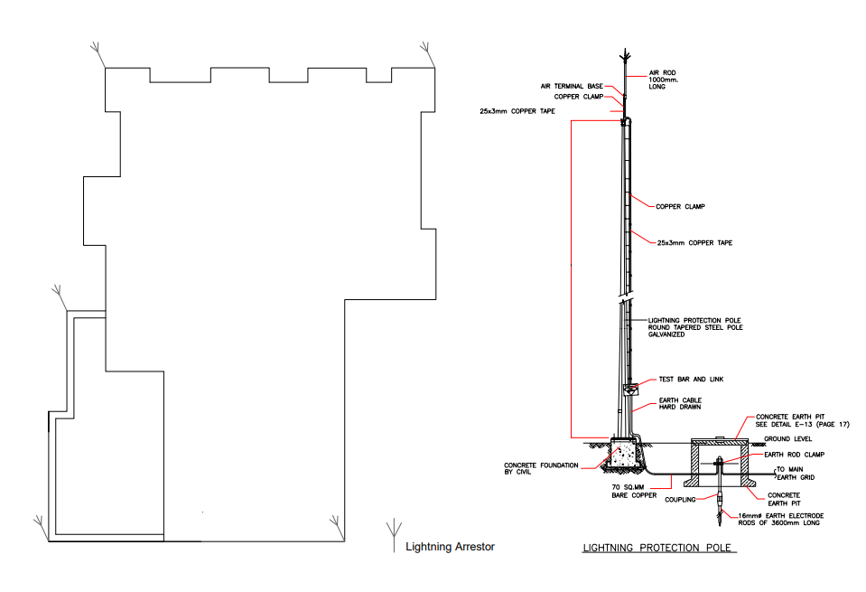

# *SMOKE DETECTOR SYSTEM*

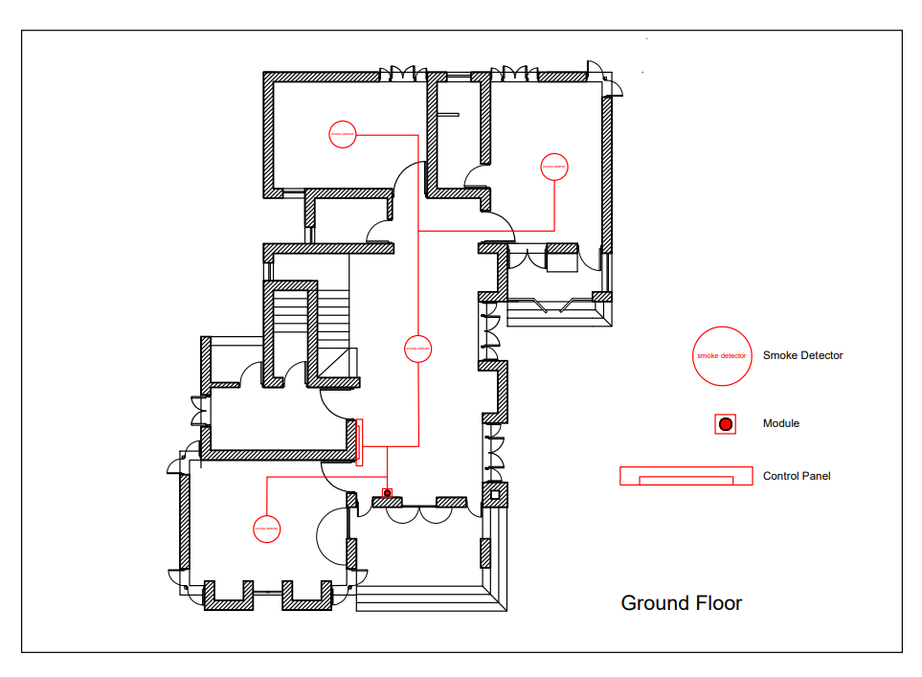

# *GROUNDING TECHNIQUE*

# *LIGHTING SYSTEM*

**For Ground floor**:

## Dining

Area=236.89 sqft = 22 m2

E=100 lumen/m2

Flux=700 lumen

Number of lights= 3.14

**1 tube light and 2 boundary wall light**

## Living Room

Area=218.46 sqft = 20.29 m2

E=100 lumen/m2

Flux=700 lumen

Number of lights= 2.89

**2 tube light**

## Kitchen

Area=93.68 sqft = 8.7 m2

E=100 lumen/m2

Flux=700 lumen

Number of lights= 1.24

**1 Tube light**

## Toilet

Area=37.08 sqft = 3.44 m2

E=100 lumen/m2

Flux=700 lumen

Number of lights= 0.49

**1 Boundary wall light**

## FOYER

## 

## Veranda

Area=27.6 sqft = 2.56 m2

E=100 lumen/m2

Flux=700 lumen

Number of lights= 0.36

**1 Ceiling light**

**For First Floor:**

## Living Room

Area=218.46 sqft = 20.29 m2

E=100 lumen/m2

Flux=700 lumen

Number of lights= 2.89

**2 tube light**

## Toilet

Area=37.08 sqft = 3.44 m2

E=100 lumen/m2

Flux=700 lumen

Number of lights= 0.49

**1 Boundary wall light**

## Dining

Area=236.89 sqft = 22 m2

E=100 lumen/m2

Flux=700 lumen

Number of lights= 3.14

**1 tube light and 2 boundary wall light**

## TERRACE

Area=286.32 sqft = 26.6 m2

E=100 lumen/m2

Flux=700 lumen

Number of lights= 3.8

**4 Ceiling light**

## BALCONY

Area=27.6 sqft = 2.56 m2

E=100 lumen/m2

Flux=700 lumen

Number of lights= 0.36

**1 Ceiling light**

## BALCONY

Area=27.6 sqft = 2.56 m2

E=100 lumen/m2

Flux=700 lumen

Number of lights= 0.36

**1 Ceiling light**